
©PIXEL Multimedia

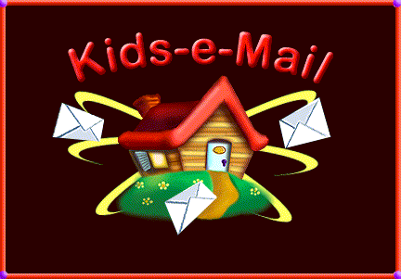

User’s Documentation

February, 98

CONFIDENTIAL

How to Install Kids-e-Mail

To install Kids-e-Mail, double click on KEM executable file and follow the installer instructions. It is recommended to choose typical installation. In the last stage of the installation, you may choose to have a Kids-e-Mail icon on your computer desktop, it is recommended to do so.
Kids-e-Mail allows you to setup users mailboxes and family e-mail settings during the installation process, it is recommended to do so. Detailed instruction of setting up mailboxes and family settings are found in the settings sections (2.1, 2.2).
Kids-e-Mail may be executed either by clicking on the icon on desktop or via start menu -> programs -> Kids-e-Mail.

Running Kids-e-Mail for the first time

When running Kids-e-Mail for the first time, the first screen you get is the family desktop. If you didn’t set-up users and family e-mail settings during the installation process, you will have to do so in order to begin working with Kids-e-Mail. To set-up users mailboxes and family e-mail settings, both accessible when clicking on the ‘Settings’ button in the utility tool bar (left side of the screen) from family desktop. Note that this procedure is designed to be performed by an adult.
When screen resolution is set to be larger than 640*480 you may minimize the application using the standard minimize button on the upper right side of the window. You may also close the program by using the standard close button on the upper right side of the window.

Mailboxes Settings:

First Time You Run Kids-e-Mail:
The first screen displayed is the family desktop with the Administrator mailbox.

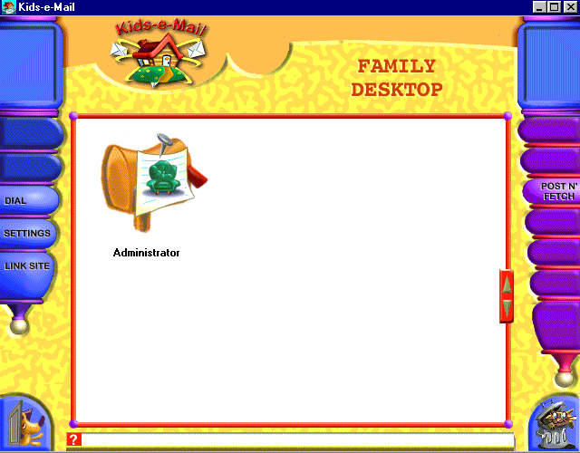

Family Desktop Screen

First step in the configuration process is to set the users’ mailboxes. To do so, click on the ‘Settings’ button in the utility tool bar. Note that you should set at least one user (mailbox) to start using Kids-e-Mail.
To add a mailbox click on the ‘New’ button and type in the user’s name. The user will then appear in the users list with a default icon. To set the user’s settings, select the user by clicking on the user’s icon, and set the options according to your preference. Kids-e-Mail offers three default settings (simple, regular and advanced) in addition to custom settings. You may set user’s personal icon, by clicking on ‘My Icon’ button and selecting a desired icon (select and click OK or double-click). You may create as many mailboxes as you need (according to number of users in the family that will be using Kids-e-Mail) by repeating this operation.
Save your mailbox settings by clicking on the ‘Save’ button, and click on the Family Settings tab to continue configuring Kids-e-Mail.
Note: If you set-up users mailboxes during the installation process, these users will already appear on the family desktop the first time you use Kids-e-Mail. You may then use the Mailbox settings to change the different settings of these users.

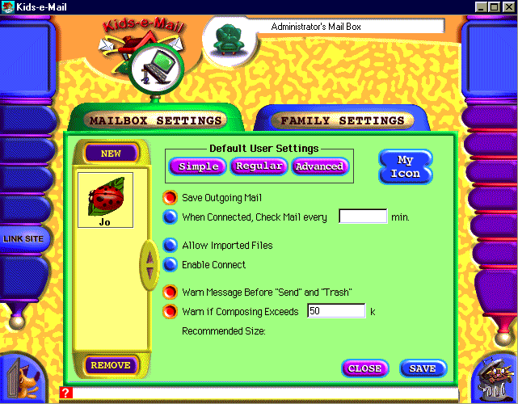
Administrator’s Mailbox Settings

After The First Time You Run Kids-e-Mail:
Whenever you wish to add a mailbox to Kids-e-Mail, go to mailbox settings from family desktop.
These settings should remain untouched unless you wish to add new mailboxes to the family or change the personal settings of one of the mailboxes. Changing personal settings is allowed from the personal mailbox as well.

Family Settings:
The second step in the setting and configuration process is to set family settings. To do so, click on Family Settings tab in the setting window.
Kids-e-Mail Family Settings are similar to familiar “set-ups” for standard e-mail readers. It establishes the basic family settings: e-mail address, mail user name and password, and mail server settings. Fill in the information and save the settings.
Note: If you set-up the family e-mail settings during the installation process the information will already appear in the family settings window.
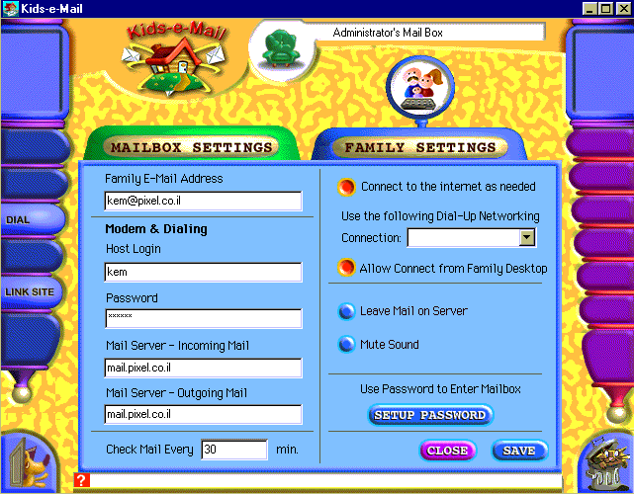

Administrator’s Family Settings

If you wish to secure the mailbox and family settings (allow access only with password) set password in Family Settings screen. Setting a password will secure access both to the administrator mailbox and to mailbox and family settings.

About your e-mail addresses using Kids-e-Mail:

To feature multiple mailboxes Kids-e-Mail uses a filter.
Addresses used for external incoming mail:
Kids-e-Mail looks for the user's name (personal mailbox) in the free text field before the Internet mail address. If the addressee is, for example,
John <kem@kidsEmail.com>, the filter directs the message to John's personal mailbox accordingly.
For cases in which an incoming message does not have a personal mailbox address (only kem@kidsEmail.com), the message will be received in family's Administrator mailbox where he/she may redirect it to the appropriate mailbox. (See detailed explanation later).
Addresses used for external outgoing mail:
Kids-e-Mail sends mail out if it recognizes an Internet e-mail address (kem@kidsEmail.com).
Incoming and outgoing mail within the family:
If an internal address is filled, Kids-e-Mail will send the message within the family (off-line), therefor when sending messages to other family users, all you need to type in is the internal user name (for example: John) and send the message.

Once you configured the family mail settings, save them, close the setting window and return to family desktop. All the mailboxes you have set will now appear on the family desktop. To enter the personal mailbox, click on the desired mailbox.
These settings should remain unchanged unless you change your family mail account or add a user name or password of your mail account.

How To Write, Send and Manage Your Mail:
All your mail messages are managed in your Personal Mailbox. To enter your personal mailbox, click on your mailbox on family desktop screen.

How to Create a Message:
To create your own messages, click on ‘Compose’ button in the message toolbar (right side of the screen).
The composing environment is designed to allow children to create e-mail messages featuring colored text, backgrounds, images, animation and sound stickers.

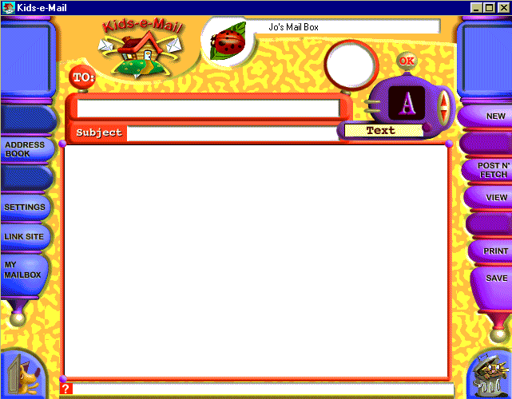

The Composer

The Message Header
The message header contains the subject of the message and the address it should be sent to. You may fill in the address (the e-mail address of the recipient) either by typing the address in, or by clicking on the ‘TO:’ button that serves as a shortcut to your personal address book (see explanation later). To fill in the subject of the message, simply type it in the subject field.

Composing the Message
Click on the toolbox arrows to browse through the available composing tools. To select a tool, click on the ‘OK’ button, or on its icon or on the text describing the tool. Selecting a tool will open up a tool window presenting available options. Note that these tool windows are 'floating', so you may continue working on your message when the tool window is open. Some tool windows feature a few different options (for example the stickers tool window features animation stickers, image stickers and greeting stickers). To switch between these options, select the desired tab. To drag a tool window, click on the selected tab indicator (on top of the current selected tab) and drag the window. Selection of formatting options (for example text color) is performed by double click on the desired option, or select the desired option and click on the ‘Apply’ button. Adding a sticker to the message (image, animation, greeting or sound) is performed by drag and drop into the message. Closing of a tool window is performed be clicking on the ‘Close’ button or by selecting another tool.

Tool Box features are:

Formatted Text- user’s setting of text size, color and style. You may set these before typing in the text, or after. If you wish to format the text after you typed it in; you should select the text you wish to format. Copy, Cut and Paste of text are available using keyboard shortcuts (Ctrl C, Ctrl X, Ctrl V). To delete text, select it and press the ‘Del’ button or ‘Backspace’ button on your keyboard.

Set Background color- you may set the message background to any color or select from our selection of patterns. To select a color, simply double click on the desired color OR select a color and click the ‘Apply’ button. If you wish to have a pattern background for your message, select the pattern tab, scroll through the pattern library and select a pattern either by double clicking the desired one or by selecting it and clicking the ‘Apply’ button.

Add stickers to message- adding image stickers, animation stickers and greeting stickers is performed by selecting the desired sticker in the tool window and dragging it into the message. Note that in the massage you may re-locate the stickers by dragging them to the desired location. You may drag stickers to clear areas only (an area with no sticker in it)- dragging stickers to a location that will overlap another sticker is not allowed. If you try to locate a sticker overlapping another sticker, it will ‘stick’ to its previous location and a sound effect will follow this action.
To switch between different available types of stickers, click the desired tab.

Add sound stickers- there are two types of sound stickers. One type is the music stickers, that allow you to include a music theme in your message (in MIDI format). To listen to the music stickers, keep the mouse down on the sticker in the Sound tool window, music will -play until you stop holding the mouse button down. To add a music sticker to your message drag the sticker onto your message (like other stickers). The second type of sound stickers is a recorded message sticker. You will need a microphone to perform recording. Simply click on the recording button, and then record your message (maximum 5 seconds long). You may listen to the message by clicking on the ‘Play’ button and add it to letter by clicking on the ‘Add to Letter’ button.
Note that sound stickers may be located (by dragging) anywhere in the message. You may drag stickers to clear areas only (an area with no sticker in it)- dragging stickers to a location that will overlap another sticker is not allowed.

Clear the page to clear the message page. Note that the message header (TO: and FROM: fields) remain filled.

Import files- this feature allows adding personal media to your message. Imported material may include graphics, animation or sound files created in any external software into the user’s message. By utilizing this option, the user may add a scanned photo, create new graphics or music. Note file formats that are allowed in import are: GIF for images, MIDI for sound and WAV for recordings.

Trash- to delete an object (sticker) from your message, simply drag it to the trash.

While in the composer, the composed message may be saved, sent, printed or viewed these options are available in message tool bar:

New- To create a new message.
Save- will save the message into your draft box.
Send- will send the message to the family shared out box. Note that messages will be sent out from the shared Out box, only after a connection to the Internet is established and a Post N’ Fetch operation is performed, to contact your mail server.
Post N’ Fetch- contacts the mail server, checks for new mail and sends all outgoing mail in shared out box, for ALL family users. Only after you perform this operation, the messages are actually sent out. You must connect your ISP (by clicking Dial in the utility tool bar) BEFORE you perform the Post N’ Fetch operation.
Print- will print out your message (note- No Printer- No Printing).
View- will display the message in its sending format, which is HTML format (the format the message is sent).

How to Send Messages:
To send a message to SOMEONE IN THE FAMILY, click on the ‘Send’ button in the message toolbar. This will automatically send the message to the family member’s mailbox.

To send a message to ANY INTERNET ADDRESS- click on the ‘Send’ button in the message toolbar. This will put the outgoing message in the shared out-box. Messages are saved in the shared out-box until you establish a connection (by clicking on Dial in the utility tool bar) and are sent out only after contact with your mail server is established by clicking on Post N’ Fetch in the message tool bar.
Note that Kids-e-Mail uses your standard computer dialer to connect to the Internet. The dialer should be set properly before used in Kids-e-Mail (see more information in the technical appendix).
After establishing the connection, contacting the mail server and receiving and sending mail, you may disconnect from the Internet by clicking on the ‘Disconnect’ button in the utility toolbar.
For young users, it is recommended that parents connect to the Internet and contact the mail server after child completed composing messages and sent them.

How to Receive Messages:
To receive messages you need to establish a connection and contact your mail server. To establish the connection, click on Dial in the utility tool bar. After connection is established your arriving mail will be downloaded, by clicking on Post N’ Fetch in the message tool bar. Incoming messages will appear in your In-Box.

The In-Box:
The In-Box shows all received messages. Each message presents sender’s name, address, subject and date that message has been sent. Unread messages are marked, as sealed envelopes. Message management options are the following:
Compose a message- select it to compose a new message.
View a message- select it and click on View in the message toolbar or double click on the message.
Reply to a received message- select it and click on Reply in the message toolbar. This operation will open the composer screen with the address of the sender.
Print a message- select it and click on Print in the message toolbar.
Delete an incoming message- select it and click on the trash.
Post N’ Fetch- contacts the mail server, checks for new mail and sends all outgoing mail in shared out box, for ALL family users. Only after you perform this operation, the messages are really sent out. You must connect your ISP (by clicking Dial in the utility tool bar) BEFORE you perform the Post N’ Fetch operation.

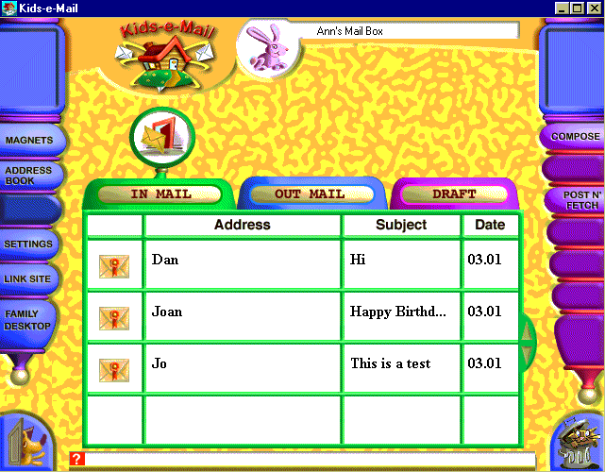

In-Box

The Out-Box
The Out-Box shows all your sent messages. Each message item shows addressee name, address, subject and date that message was sent.
Message management options are the following:
Compose a message- select it to compose a new message.
Print a message- select it and click on Print in the message toolbar.
View a message- select it and click on View in the message toolbar or double click on a message.
Post N’ Fetch- contacts the mail server, checks for new mail and sends all outgoing mail in shared out box, for ALL family users. Only after you perform this operation, the messages are really sent out. You must connect your ISP (by clicking Dial in the utility tool bar) BEFORE you perform the Post N’ Fetch operation.
Delete saved message- select it and click on the trash.

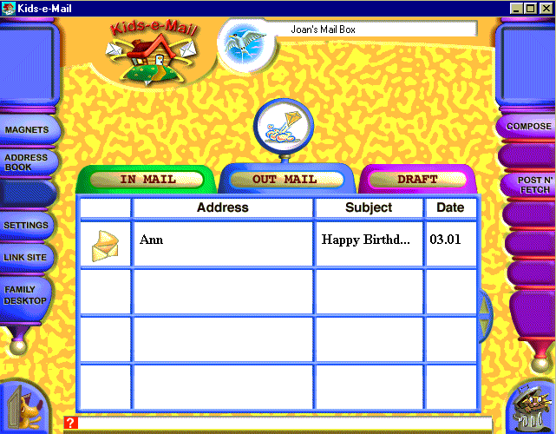

Out-Box

The Draft-Box
The Draft-Box shows all composed and saved messages (but not yet ready to be sent). Each message item shows addressee name, address, subject and date that message was composed and saved. When the ‘Send’ button is clicked, the saved message is moved from the Draft-Box to the Out-Box.
Message management options are the following:
Compose - select a message in the draft box and click on the ‘Compose’ button in the message toolbar to edit a saved message.
Send- will send the message to the family shared out box. Note that messages will be sent out from the shared Out box, only after a connection to the Internet is established and a Post N’ Fetch operation is performed, to contact your mail server.
View a message- select it and click on View in the message toolbar or double click on a message.
Post N’ Fetch- contacts the mail server, checks for new mail and sends all outgoing mail in shared out box, for ALL family users. Only after you perform this operation, the messages are really sent out. You must connect your ISP (by clicking Dial in the utility tool bar) BEFORE you perform the Post N’ Fetch operation.
Print a message- select it and click on Print in the message toolbar.
Delete saved message- select it and click on the trash.

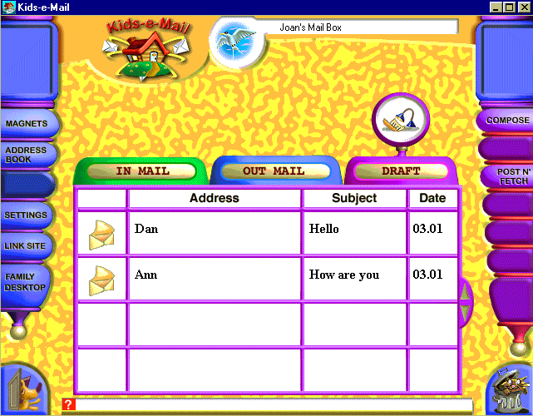

Draft-Box

Other Features

The Personal Address Book:
The personal address book allows you to create a list of frequently used addresses. It will also link an icon to each address. Selecting an address is a short and easy procedure. Kids-e-Mail features 60 unique personal icons for users to select from.
To create your own address book, click on the Address Book in the utility bar (when you are in your personal mailbox). Click on the ‘Add’ button to add a new addressee. Fill in the name and e-mail address. Click on the ‘Icon’ button, to set an icon, select an icon (double click or select and click on the ‘Apply’ button) and click OK. To modify an existing addressee, double click it, and change the parameters. Your list of addressees will appear when you click on the 'To:' button in the Composer.
For young users, it is recommended that parents fill in the addresses in the address book together with the child, so the child may pick the icon and the parent will insert the e-mail address.

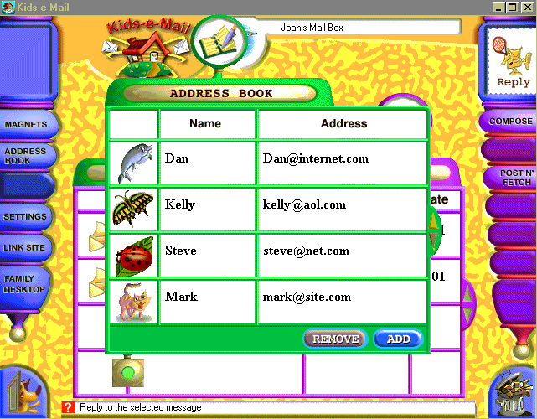

Personal Address Book

About Addresses in Kids-e-Mail
To set an address for someone WITHIN THE FAMILY set the address to the personal mailbox name (for example: John). Note that your family members (those that have a personal mailbox) will automatically appear in your address book.
To set an address for someone OVER THE INTERNET that is using Kids-e-Mail, set the name to the personal mailbox (for example: John) and the address to the family mail account (for example: kem@kidsEmail.com).

Personal Settings :
This function allows users to personalize their private boxes by setting the personal icon, secure your own mailbox by setting a password to personal mailbox and setting personal preferences.

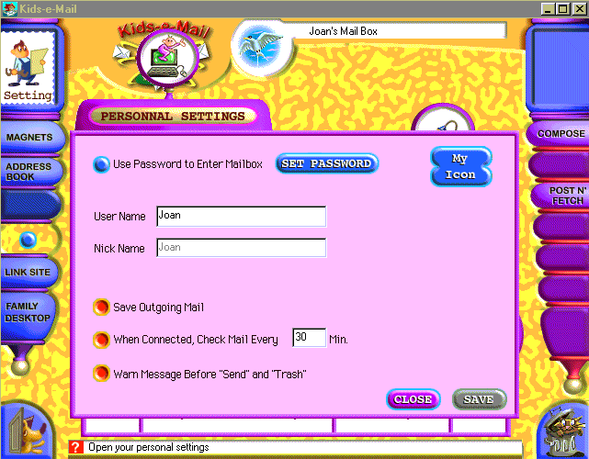

Personal Settings

The Administrator’s Mailbox
 The Family Administrator has an additional mailbox, which is accessible from family desktop. This mailbox allows the Administrator to redirect mail that arrived in the family e-mail account without any indication of the specific user.

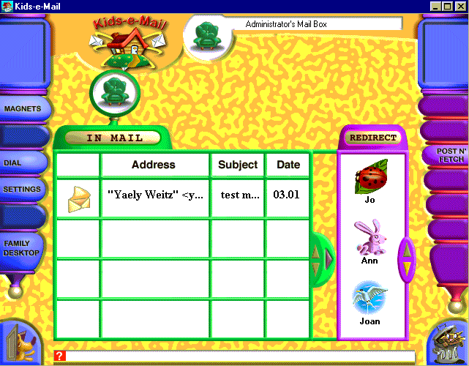

Administrator’s Mailbox

If you wish to secure the administrator mailbox (allow access only with password) go to Family Settings (by clicking on the ‘Settings’ button in the utility tool bar on family desktop) and set password. Setting a password will secure access both to the administrator mailbox and to mailbox and family settings.

To redirect mail messages, select a message, then select a user's mailbox and click on the redirect arrow.
Message management options are the following:
Print a message- select it and click on Print in the message toolbar.
View a message- select it and click on View in the message toolbar or double click on a message.
Post N’ Fetch- to check if new messages arrived, contacts the mail server only after connecting your ISP (by clicking Dial in the utility tool bar) and then perform the Post N’ Fetch operation.
Delete saved message- select it and click on the trash.
Post N’ Fetch- contacts the mail server, checks for new mail and sends all outgoing mail in shared out box, for ALL family users. Only after you perform this operation, the messages are really sent out. You must connect your ISP (by clicking Dial in the utility tool bar) BEFORE you perform the Post N’ Fetch operation.

The Electronic Fridge Magnets
This internal communication center allows members of the family to leave short, informative messages for each other.
To create a magnet message, click on Magnets in the utility tool bar. The Magnets window will open. Kids-e-Mail features three different types of messages: ‘Note!’ which is a reminder message, ‘Out ‘n About’ which is a format of a note describing where I am and when I’ll be back, and ‘Phone Calls’ which is a phone call message. To select a desired type, click on its’ tab. All you need to do is fill in the form (use the TO: and FROM: to select the addressee and sender). When sending a magnet message from your personal mailbox, Kids-e-Mail will fill the sender’s name automatically. To send a magnet message, click the ‘OK’ button on the magnets window or on the ‘Send’ button in the message tool bar.
Magnet messages that you sent are presented in your out-box, and ones you receive in your in-box.

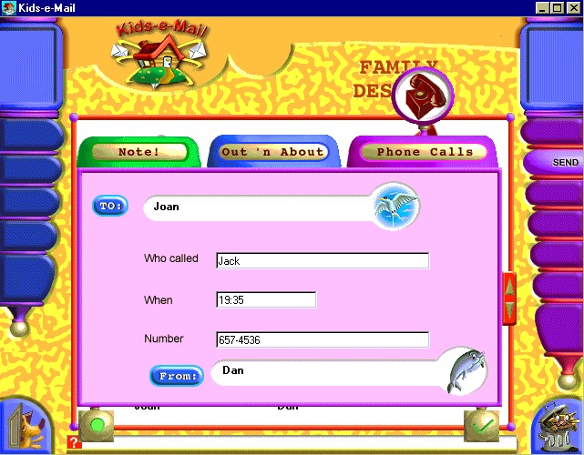

Phone Message Fridge Magnet Form

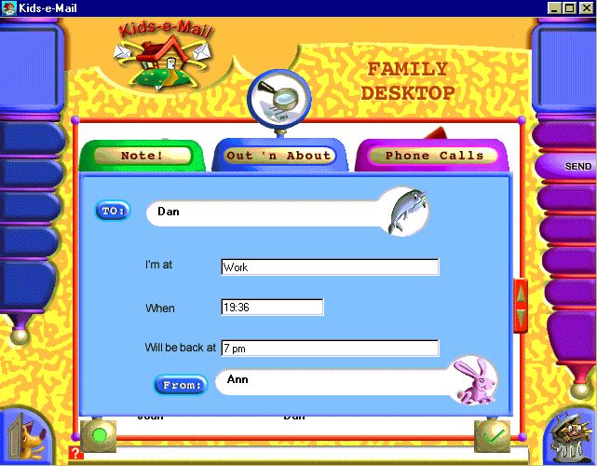

Out N’ About Message Fridge Magnet Form

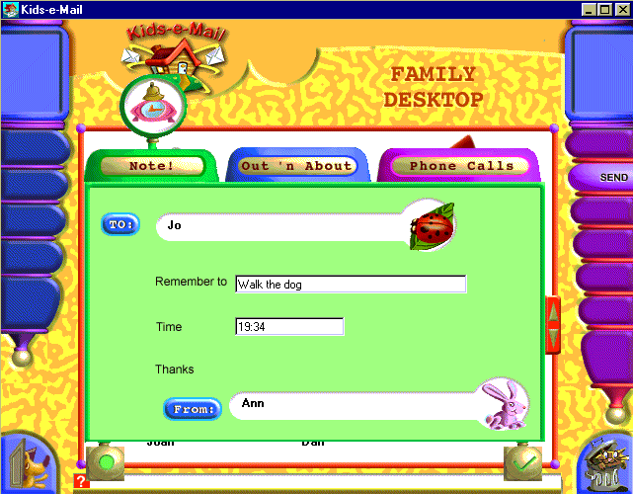

Note! Message Fridge Magnet Form

Fridge Magnets messages will appear in the Kids-e-Mail Screen Saver.

New Mail Notices

Kids-e-Mail will indicate new mail for any of the users in three ways:
- In Kids-e-Mail on the Family Desktop, mail indicators in personal mailboxes of users who have messages will be up.
- The Kids-e-Mail Screen Saver calls up users that have new mail.

Kids-e-Mail Screen Saver

If you have installed the Kids-e-Mail screen saver during installation, you need to set it in your system. To do so, click on the right mouse button when on computer desktop, or run Display from system control panel, go to screen saver tab and set the screen saver to KEMSaver.
Kids-e-Mail screen saver presents new message alerts as well as all magnet messages in a unique dynamic animated display.

FAQ

I forgot the family settings password. How can I enter the settings window without using the password?

In order to cancel the use of password follow these steps:

- Go to start menu/run
- Type in : regedit
Click 'OK'
- The registry editor will open.
- In the registry editor window (Left side of it) select:
- HKEY_CURRENT_USER/Software/Pixel/Family Email/Users/Administrator
- In the right side select:
Use Password
- In the window that opens change the value data field from 1 to 0
- Close the registry window.

When dragging stickers, the colors of the sticker changes

This is a known bug in the current Kids-e-Mail version when your monitor is set to 16BIT color or 24BIT color. After re-locating the sticker, it returns to its original colors.

When importing an image, it’s colors changed

This problem occurs because the imported image is in a different color palette than Kids-e-Mail.

Technical Appendix

Kids-e-Mail Message Structure

Kids-e-Mail creates multimedia messages that are based on standard HTML files and media files that are sent as attachments.

Attachment Files Format and size:
- Screen Compositions are in HTML files about 8K.
- Colored backgrounds are in tiled GIF files about 6K.
- Stickers of graphic images and animated segments are in GIF files about 6K for image and 24K for animation.
- Formatted text is part of the HTML standard (included in HTML file).
- Recorded messages (11.25 MHz, 8 bit) are WAV files about 50K.
- Music is taken from MIDI files about 6K.

The message is constructed from a standard mail message and Mime encoded attachment files.

Receiving Kids-e-Mail Messages By Another Kids-e-Mail User

When a new message arrives, the Kids-e-Mail mailer handles the message, and the attachment files are saved in a specified directory. At this point, the message is registered in the database, and it appears in the In-Box list of new messages. When the user wants to read the message, they click on the received message icon, and the HTML multimedia message (HTML file plus media files) is displayed on screen.

Receiving Kids-e-Mail Messages By Other Mailers

Reading Kids-e-Mail multimedia messages without Kids-e-Mail requires the following on the recipient end:

- A mailer capable of receiving Mime encoded attachments
- A WWW browser (such as Internet Explorer, Netscape Navigator)
- MIDI player in the WWW browser

Messages arrive to recipients as described above. The user clicks on the message in his mailer (e.g. Eudora) and then his Web browser reads the multimedia message. This reading may be achieved either by clicking on the HTML file attachment in the message (if mailer supports this feature), or by directly opening the HTML file (not using the mailer). Some mailers require that the user save the attachment files and only then open the HTML file with the browser. In order to read such a message receiver will need to save all the attached files to an empty temporary directory and open the HTML attachment file using your browser.

If the recipient does not meet the above requirements, the text in the multimedia portion of the message will appear as text in a standard mail message. At the bottom of each message, the information needed to read the multimedia message would appear (For example: To read this message, double click on the E200A143.HTM file or open this file with your Web browser).

Receiving Mail Created by Other Programs
When a Kids-e-Mail user receives a standard mail message created by a standard mailer, the text content of the message will be displayed by Kids-e-Mail reader. IF the message includes attachments, they will appear as linked text in HTML and when clicking on these attachments the files will open. If an HTML file attachment is sent from another mailer to Kids-e-Mail, it may be opened either using Kids-e-Mail viewer or by opening your Internet browser.

What if the Family has other e-mail Programs?
A family may have one Internet account and use several mail reading programs, without worrying about missing messages. For example, Dad uses Z-Mail to get his office mail at home, and the kids use Kids-e-Mail. In such a case, the user may choose “leave mail on server” in family settings.

When "Leave mail on server" is selected, the message will stay on mail server, so if a parent received a message using Kids-e-Mail, it is left on the mail server and when he/she opens the other mailer (Eudora, Netscape etc.) the message will appear again (and vice versa).

When "Leave mail on server" is not selected, once a message is read in one of the mailers, it will not appear in the other mailer. So in case a parent received a message using Kids-e-Mail, when he/she opens the other mailer (Eudora, Netscape etc.), the message will not appear again (and vice versa).

Kids-e-Mail Multi-User System
Kids-e-Mail arranges personal mailboxes according to the family settings.

For internal communications, Kids-e-Mail transfers messages within the database.

For external communication, Kids-e-Mail uses a filter. Kids-e-Mail looks for the user's name in the free text field before the address. If the addressee is, for example, John <kem@kids-e-mail.com>, the filter directs the message to "John's" personal mailbox accordingly. For cases in which an incoming message does not have a personal mailbox address, the family's Administrator will receive and route the message to the appropriate personal mailbox.

Using Various Mail Services

Kids-e-Mail supports all TCP-IP mail servers supporting POP3 protocol.

Sending Mail

Compression Methods
Graphics files are in GIF format and compressed into LZ 77 format.
HTML and MIDI files are compact files (ASCII and binary, accordingly).
WAV (user-recorded) files are limited to five seconds and are sent uncompressed.

Connecting to your ISP
Kids-e-Mail uses your standard computer dialer to connect to the Internet. The dialer should be set properly BEFORE using in Kids-e-Mail, it should include the number to dial, user name and password, modem setting etc.
After establishing the connection, contacting the mail server and receiving and sending mail, you may disconnect from the Internet by clicking on the ‘Disconnect’ button in the utility toolbar.

Sending and Receiving Mail
When users send messages within the family, the Kids-e-Mail mailer re-directs the messages from the personal Out-Boxes of the senders to the In-Boxes of the recipients.

When users send messages out of the family, by clicking on the ‘Send’ button, the message is transferred to a shared Out-Box. Note that the message remains in the shared Out-Box until a connection is established and contact to the mail server. The shared Out-Box holds all family member’s sent mail.
When one of the users connects and contacts the mail server, the mailer sends ALL the external messages in the shared Out-Box and receives incoming messages for ALL the users in the shared In-Box and re-directs messages to the proper mailbox.

